Venue（会议地点）：
A12, Minggugong Campus, Nanjing University of Aeronautics and Astronautics
南京航空航天大学明故宫校区A12楼

Transportation（交通方式）：
（1）Nanjing Lukou Airport (南京禄口机场) ---- Minggugong Campus, Nanjing University of Aeronautics and Astronautics (南京航空航天大学明故宫校区)
Route 1: by TAXI, about 120 RMB.
Route 2: by Subway. At the airport, taking Line S1 of Nanjing Subway to Nanjing South Railway Station, then taking Line 3 to Daxinggong Station, finally taking Line 2 to Minggugong Station.

路线1：从禄口机场直接打的到南京航空航天大学明故宫校区，大约120块钱。
路线2：在禄口机场乘坐S1号地铁到达南京南站，转地铁3号线到达大行宫站，转地铁2号线到达明故宫地铁站，步行225米到达终点。

（2）Nanjing South Railway Station（南京南站）---- Minggugong Campus, Nanjing University of Aeronautics and Astronautics (南京航空航天大学明故宫校区)
Route 1: by Subway. At the Nanjing South Railway Station, taking Line 3 to Daxinggong Station, then taking Line 2 to Minggugong Station.
Route 2: by TAXI, about 34 RMB.

路线1:在南京南站乘坐地铁3号线到达大行宫站，转地铁2号线到达明故宫地铁站，步行225米到达终点。
路线2：直接从南京南站打的到南京航空航天大学明故宫校区北门，打的费约34元。

（3）Nanjing Railway Station（南京站）---- Minggugong Campus, Nanjing University of Aeronautics and Astronautics (南京航空航天大学明故宫校区)
Route 1: by Subway. At the Nanjing Railway Station, taking Line 3 to Daxinggong Station, then taking Line 2 to Minggugong Station.
Route 2: by TAXI, about 18 RMB.

路线1：在南京站乘坐地铁3号线到达大行宫站，转地铁2号线到达明故宫地铁站，步行225米到达终点。
路线2：直接从南京站打的到达南京航空航天大学明故宫校区北门，打的费约18元。

（4）南京长途汽车站-------南京航空航天大学明故宫校区
路线1：直接打的从南京长途汽车站到达南京航空航天大学明故宫校区，打的费约18元。

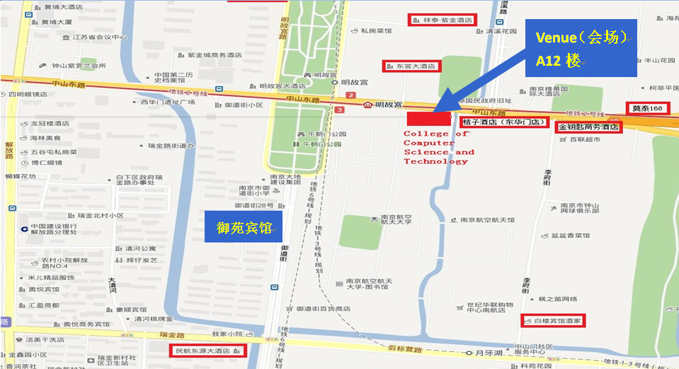
Map of Minggugong Campus, Nanjing University of Aeronautics and Astronautics
南京航空航天大学明故宫校区简图

